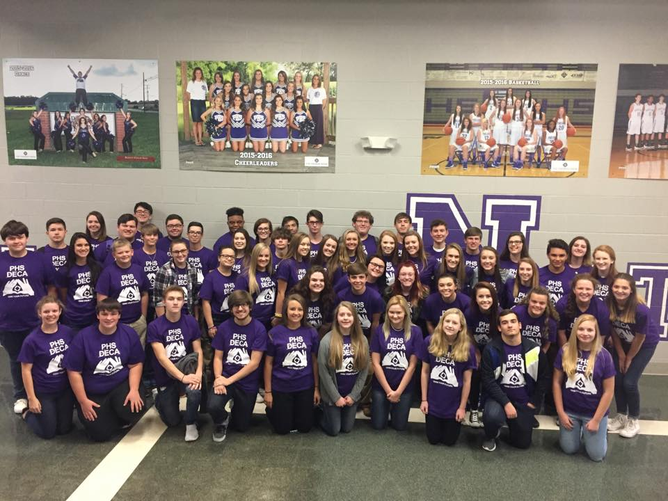
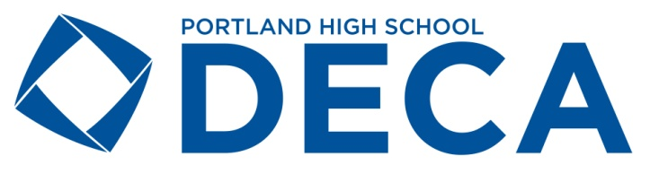
What is DECA?
- DECA is a student organization for marketing students. It is a basic component of a Marketing Education program which supports and enhances related school based and work-based learning.
- DECA provides students with skills and knowledge to succeed in the new global economy.
- DECA is a local, state, and national organization of goal-oriented youth with career interests in marketing, management, entrepreneurship, hospitality, and finance.

What are the benefits for a business to partner with Portland High School DECA?
Silver Partnership Level $100
Silver Level Partnership Perks:
- Framed Active DECA Membership Certificate to display in your business
- Professional Membership in DECA which includes a quarterly subscription to DECA Direct magazine with provided address (PHS DECA has been featured in the magazine several times!)
- Subscription to our PHS DECA Digital Newsletter delivered between 6-8 times a year.
- Quarterly recognition for your business on our Facebook, Instagram, and Twitter social media sites, which have a combined following of over 1200 community members and growing daily!
- Invitation to judge at PHS DECA competition in November
- Invitation to PHS annual catered Breakfast with a Business in Spring Semester
- Chance to make a difference in individual students lives and serve as a role model in the community

Gold Partnership Level $200
Gold Level Partnership Perks (Includes Everything in Silver Level Plus):
- Your logo on the back of our chapter t-shirts, which are worn by students, parents, teachers, business partners, and various Sumner County Schools faculty and administrators
- A PHS DECA chapter t-shirt in the size of your choosing!
- Monthly social media recognition on our PHS DECA social media sites!

Platinum Partnership Level $500
Platinum Level Partnership Perks (Includes Everything in Silver and Gold Levels Plus):
- Your logo on our chapter banner that we take pictures with throughout the school year and during competition
- A plaque with your business’ name on our Wall of Fame in the Marketing Classroom. Plaque will also be displayed at DECA social events, PHS DECA competition, Breakfast with a Business, and various other DECA events.
- A special profile highlighting your business in one edition of our digital newsletter

Yes! We want to be a PHS DECA Business Partner for the 2019-20 school year!

Name of Business:
Contact Person:
Mailing Address:
Email Address:
Phone Number:

Twitter Handle (if applicable):
Facebook page (if applicable):
Instagram username (If applicable):

Please indicate below what level partnership you would like with PHS DECA

Silver Level $100
Gold Level $200
Platinum Level $500
___________Diamond Level $750

Please include with this form

________ Check made payable to Portland High School DECA for appropriate level amount.
________ Logo submitted on business card or paper copy or…
________ Logo submitted electronically by e-mail to marybeth.allen@sumnerschools.org
________ T-Shirt Size (if Gold, Platinum, or Diamond level partnership chosen)

(**Please note if you were our business partner last year, we already have your logo on file electronically, and you do not need to send in another logo this year unless it has changed**)

Receipt will be mailed to you upon payment for tax deduction purposes!

Submit to Mary Beth Allen, Marketing Teacher and DECA Advisor
FORM, LOGO, AND PAYMENT MUST BE RECEIVED NO LATER THAN FRIDAY, SEPTEMBER 6th FOR LOGO ON SHIRT
Phone: 615-325-9201 ext: 31349
E-Mail: marybeth.allen@sumnerschools.org
Address: Portland High School
Attn: DECA
600 College Street
Portland, TN 37148
or contact Ms. Allen if you would like a DECA Officer to pick up

